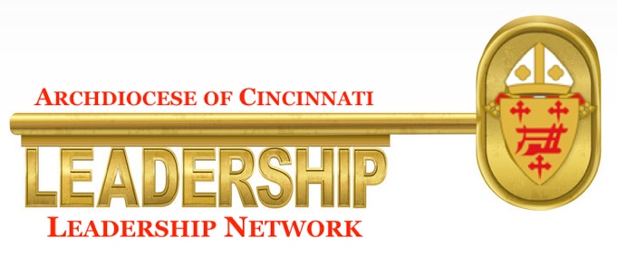
The Leadership Network in the Archdiocese of Cincinnati has been created to support pastors as they meet the demands of shepherding their parish or pastoral region. Network members bring years of leadership experience and expertise along with a passion for Christ and the Church to their service to pastors in our Archdiocese. The Network is ready to schedule time with any pastor, new or seasoned, offering coaching and personal support in areas that include: leadership, management, finance/administration, organizational development, strategic planning, and problem analysis/solutions. You may contact network members via Leisa Anslinger, Associate Director for Pastoral Life, at 513.263.6693. Leisa knows each network member personally and will be happy to help you discern a member who can address your pastoral leadership needs.
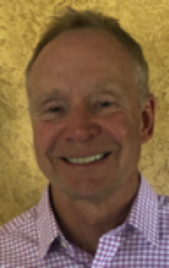
Mark A. Collar, owner of Collar, Ltd. Mark was the board chair and director of marketing for the start-up Invisible Ink Tattoo Removers; previously President, Global Pharmaceuticals and Personal Health, a multi-billion dollar global division of the Procter & Gamble Company, and currently a senior executive at the Fellowship of Catholic University Students (FOCUS).
Mr. Collar is excited to work with our pastors because he knows these talented men have not received adequate training over the years in leadership and management to fully deliver their vison for their parishes.

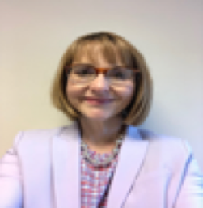
Lori Dashewich is passionate about developing and leading teams. Leadership is about serving people; people matter most within organizations. Lori has over 27 years of insurance industry experience. She is currently the Vice President and Controller at Ohio Financial Services, leading a team of over 35 professional associates.
Lori is volunteering because “I don’t believe things happen in our lives by chance. I believe God puts us in situations that link us with people we need to help do what He wants us to do. I believe God has called me to use my talents and experience to help.”
(Continue on next page)
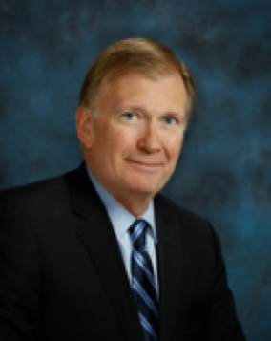
Tom Fiorini is the President & CEO of the Cincinnati Sports Club. He has a 50 year career encompassing design and urban planning; municipal government; city planning and historic preservation; real estate development; retail, banking, and club management; restaurants, and farming. He has served on Boards of Directors for 40 years and has participated on local, regional, and national CEO Rountables for 20 years. Tom says, “With assistance from Spiritual Directors I have dedicated the last chapter of my career to be a very good businessman who lives the Gospel. I would like to return the favor by assisting Clergy in implementing the teachings of Pat Lencioni in managing the business affairs of the church.”
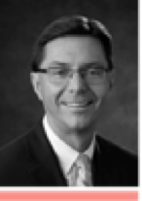

John Gruber is married and is the father of five children, ages 25-14. John is Senior Vice President, General Counsel & Secretary of Great American Life Insurance Company. He served on the Board of the Good Shepherd Catholic Montessori School for 20 years and served terms as President, Treasurer, & Secretary. John has served on the Finance Committee for Guardian Angels and St. John Fisher Parishes.
John is volunteering to provide support, encouragement, and assistance to priests with respect to the demands and opportunities to serve their parishes as servant leaders.

Thomas Gruber is Chairman and retired CEO of CareStar Holdings, Inc., a Cincinnati-based care management company providing support and software services for the chronically disabled community. Mr. Gruber is a Certified Public Accountant and graduate of Saint John’s University, Collegeville, MN earning a bachelor’s degree in accounting.
He says: “I am pleased to offer my time and counsel to priests of the Archdiocese of Cincinnati upon their request. In addition to my career as a successful entrepreneur I have experience in strategic planning, crisis management, budgeting, human resource and financial management. Most recently I supported Fr Jeff Kemper as the Chairman of the Building and Fundraising Committees for the recently constructed church at St John the Baptist, Harrison.”
(Continue on next page)

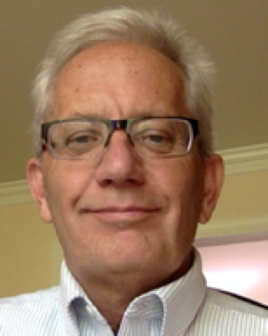
Tim Kloppenborg is Professor Emeritus of Management from Xavier University and a retired USAF Reserve Major. He has consulted, trained, and taught on six continents, and has worked in manufacturing, construction, and research. Tim has served on 6 Catholic boards and has served as president of 4 of them. He was certified as a strengths coach by the Gallup Faith Division, has written over 100 publications including 12 books, mostly dealing with leadership and/or project management. Tim is volunteering “because our Catholic Church is facing many challenges and I would like to help caring and committed priests with the leadership issues they face.”

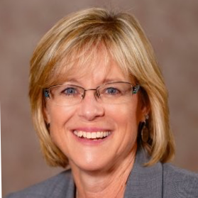
Lisa Odenbeck currently owns her own consulting/coaching business working in leadership development, career coaching, fundraising and project management for non-profits. She has spent the last 16 years working within Catholic education and organizations. Lisa served as the interim VP for Institutional Advancement, Executive Director of Development and Director of Alumni Relations at Mount St. Joseph University. Lisa holds certifications in Everything DiSC Workplace Facilitator, Leadership Council of Non-Profit Executives, and Volunteer Management. Lisa says, “I am volunteering because I believe it is time for the laity to step up and help our holy priests with the challenges they face as leaders and my love for the Catholic faith.”

Jack Overbeck joined the Kroger Co. in 1965 and served in various capacities in Cincinnati, Minneapolis, Atlanta, and Nashville. He served as Vice President of Human Resources and Labor Relations from 1979 until his retirement in 1993. Jack served on the Rebuilding and Fund Development Committees at Immaculate Heart of Mary Parish and has served on numerous search committees for local Catholic schools and other organizations. Jack serves as a ministry coach in job search and is a human resource assessment strategy coach.
Jack is committed to assisting parish pastor develop his leadership abilities, to create the successful parish leadership team, to focus on strategic direction, to confront and successfully solve managerial issues, and enhance the faith development of parish members.

(Continue on next page)
Scott Teepe Sr. is the Chairman of TP Mechanical, Teepe Family Foundation, and Teepe Family Investments. He helped create Receptions banquet facilities in 1991 as well as Pivotek, a modular building company in 2011. Scott has served on boards and led 180 employees through five days of Pathways to Leadership training over 5 years. He is a member of the Cincinnati Legatus Catholic group since 2010 and served as President in in 2016-2017.
Scott seeks to provide guidance to pastors in our Archdiocese through his years of leadership experience as a way of giving back to the Church.
