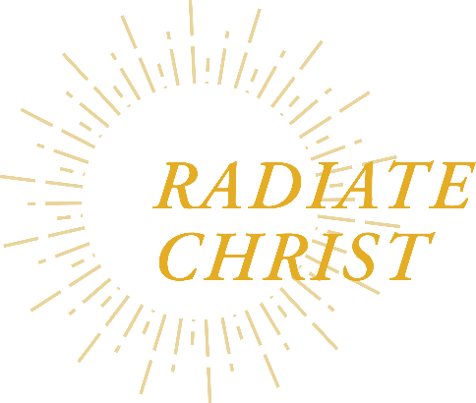

Principal Meeting
Friday, March 26, 2021
9:00 a.m. – 12:30 p.m.
Via Zoom

Agenda

8:50 a.m. Principals Log On
9:00 a.m. Welcome Susan Gibbons
9:05 a.m. Opening Prayer Mayra Wilson
9:10 a.m. Superintendent’s Report Susan Gibbons
9:25 a.m. Zoom Etiquette/Introduction Sharon Willmes
9:30 a.m. Implicit and Explicit Biases: How To
Manage it with Staff and Students* Robert Jackson
11:00 a.m. Break
11:10 a.m. Safe Environment/Virtus Update Bill Mitchell
Final Session Is for Parish Elementary School Principals Only
11:45 a.m. Best Practices for Parish/School Audits Dave Abele
12:30 p.m. Closing Prayer Deanna Gonzalez-Hermosillo

*Session Title: Implicit and Explicit Biases: How to Manage it with Staff and Students
This workshop will give educators strategies to successfully manage Implicit and Explicit Bias. Perception has become reality. During this interactive workshop administrators and other school leaders will learn the true depiction of Implicit Bias along with strategies for Diversity and Inclusion. They will learn 4 tips to managing biases, tools to build positive relationships and strategies and techniques that have been proven to work. Leaders will be challenged to self-evaluate their own thought process to see it through a different lens. Come and engage in this fun, interactive workshop and receive tools you can use right away.

