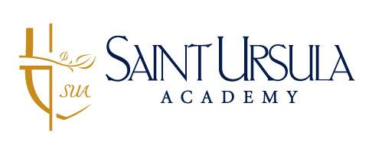
Junior Varsity Assistant Field Hockey Coach
Mission:
Saint Ursula Academy is a vibrant educational community founded on the strength of our Catholic faith and Ursuline values. Saint Ursula Academy promotes academic excellence and fosters a welcoming, respectful, and diverse community. Saint Ursula Academy graduates women filled with faith, integrity, and courage, ready to make a positive impact in the world.

Job Summary:
The JV Assistant Field Hockey Coach is responsible for building foundational skills, confidence, teamwork, and sportsmanship in student-athletes. The assistant coach serves as a positive role model who fosters the growth of the whole person—mind, body, and spirit—both on and off the field. The individual will coach the JV level of the women’s field hockey program, including summer youth camps This is a seasonal, stipend position with pay rate commensurate with experience.
Responsibilities/Duties:
- Supports, promotes, and models the mission, vision, and core Ursuline values of Saint Ursula Academy.
- Works cooperatively with the Head Field Hockey Coach, other personnel and departments to ensure a welcoming environment for students, parents, and visitors to the school.
- Plan and lead practices that develop fundamental field hockey skills and game understanding.
- Foster a positive, inclusive, and respectful team culture.
- Mentor and empower young women through athletics.
- Collaborate with the Head Coach, Varsity Coach, and Athletic Department.
- Prepare the team for competitive play while emphasizing sportsmanship.
- Supervise athletes during practices and competitions, ensuring safety and well-being.
- Communicate effectively with student-athletes, parents, and school administrators.
- Adhere to all school, league, and diocesan policies.
- Other duties as assigned.

Education/Experience:

- Bachelor's degree.
- Prior experience playing field hockey on a high school or collegiate level.

Knowledge, Skills & Abilities:
- Field hockey coaching or playing experience preferred.
- Experience working with adolescents or in a school setting.
- Commitment to the mission and values of Saint Ursula Academy.
- Strong leadership, communication, and organizational skills.
- CPR/First Aid certification, Pupil Activity Permit, and Concussion and Sudden Cardiac Arrest training (or willingness to obtain).
- Completion of required background checks and certifications.
- All religious denominations are invited to apply.

To apply, please visit https://hcm.paycor.com/l/r/F0628B3B.

