Intercessions

For what or for whom should we pray?

Lord’s Prayer

Closing Prayer

Mary, Mother of the Church and our Mother,
present our prayer of thanksgiving to your Son.
Beg from Him the graces we need to be faithful disciples
who follow Him with enthusiasm and joy.

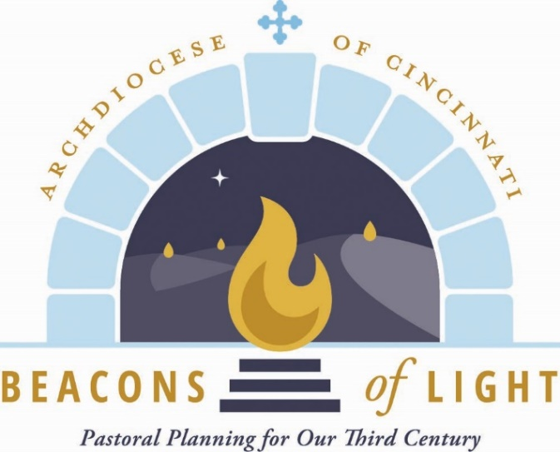
May our witness to the love of God bear fruit
in our archdiocese, parishes, homes and hearts.
Teach us to be God’s joyful witnesses,
to radiate Christ in all we do,
so that all people might know, love and follow your Son
through this life and into the next.
Amen.

May 2021

Opening Prayer

Let us pray.

(Pause for silent prayer)

Grant, we pray, almighty God,
that your Church may always remain that holy people,
formed as one by the unity of Father, Son, and Holy Spirit,
which manifest to the world
the Sacrament of your holiness and unity
and leads it to the perfection of your charity.
Through our Lord Jesus Christ, your Son,
who lives and reigns with you in the unity of the Holy Spirit,
God, forever and ever. Amen.

Reading from Sacred Scripture

A reading from the Gospel according to St. John. (Pentecost)

On the evening of that first day of the week,
when the doors were locked, where the disciples were,
for fear of the Jews,
Jesus came and stood in their midst
and said to them, “Peace be with you.”
When he had said this, he showed them his hands and his side.
The disciples rejoiced when they saw the Lord.
Jesus said to them again, “Peace be with you.
As the Father has sent me, so I send you.”
And when he had said this, he breathed on them and said,
“Receive the Holy Spirit.
Whose sins you forgive are forgiven them,
and whose sins you retain are retained.”
(John 20:19-23)

From Radiate Christ

Our immediate experience of the Church is through the people closest to us – even if we do not always think of it this way. We first experience the Church through our families: our parents, grandparents, brothers, sisters and extended family. Secondarily, we experience the Church through our friends, neighbors, co-workers, teams and classmates. These are the people God has placed in our lives, and we in theirs, to build each other up. These are the people upon whom our joyful and faithful witness can have the most effect. Jesus told us, “Where two or three have met together in my name, I am there among them” (Matthew 18:20). How true that is! When the individual members of these smaller groups radiate Christ to each other, the group takes on its own divine radiance. These small groups can then transform the larger structures they are part of: our parishes, neighborhoods, schools and workplaces. When these larger communities radiate Christ, then the Church makes Christ present to the world.

Questions for Reflection and Sharing

What connections or new insights did you gain from the readings?

What words or phrases spoke to you most powerfully in light of the call to form our parish as a beacon of light?

How might the readings influence our planning for the future?

