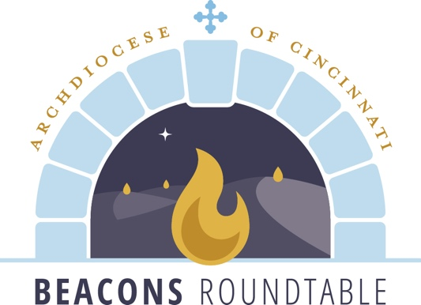

Building Belonging with Persons of Disabilities
Helpful Web Links

Sensory Friendly Mass: https://resources.catholicaoc.org/offices/office-for-persons-with-disabilities/media-events/sensory-friendly-mass

Accessible Design: https://resources.catholicaoc.org/offices/office-for-persons-with-disabilities/accessible-design

Parish Resouces: https://resources.catholicaoc.org/offices/office-for-persons-with-disabilities/resources

