Intercessions

For what or for whom should we pray?

Lord’s Prayer

Closing Prayer

Mary, Mother of the Church and our Mother,
present our prayer of thanksgiving to your Son.
Beg from Him the graces we need to be faithful disciples
who follow Him with enthusiasm and joy.

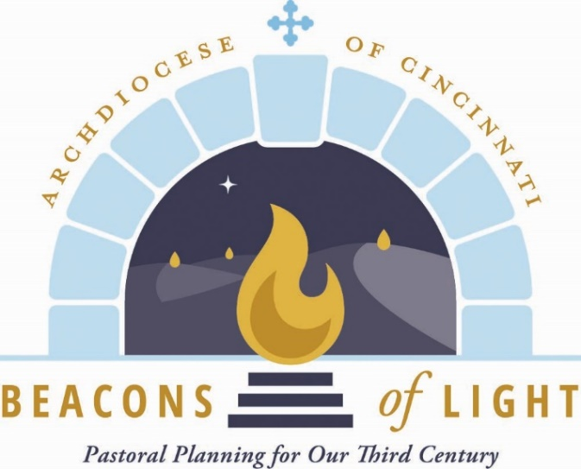
May our witness to the love of God bear fruit
in our archdiocese, parishes, homes and hearts.
Teach us to be God’s joyful witnesses,
to radiate Christ in all we do,
so that all people might know, love and follow your Son
through this life and into the next.
Amen.

July 2021

Opening Prayer

Let us pray.

(Pause for silent prayer)

Grant, we pray, almighty God,
that your Church may always remain that holy people,
formed as one by the unity of Father, Son, and Holy Spirit,
which manifest to the world
the Sacrament of your holiness and unity
and leads it to the perfection of your charity.
Through our Lord Jesus Christ, your Son,
who lives and reigns with you in the unity of the Holy Spirit,
God, forever and ever. Amen.

Reading from Sacred Scripture

A reading from the Gospel according to St. Mark.

Jesus summoned the Twelve
and began to send them out two by two
and gave them authority over unclean spirits.
He instructed them to take nothing for the journey
but a walking stick—
no food, no sack, no money in their belts.
They were, however, to wear sandals
but not a second tunic.
He said to them,
“Wherever you enter a house, stay there until you leave.
Whatever place does not welcome you or listen to you,
leave there and shake the dust off your feet
in testimony against them.”
So they went off and preached repentance.
The Twelve drove out many demons,
and they anointed with oil many who were sick
and cured them.

(Mk 6:7-13 Fifteenth Sunday in Ordinary Time)

From Radiate Christ

We are now in a time of rapid change, requiring us to be adaptable to modern needs while maintaining our commitment to Jesus Christ. This opens up a great possibility for us. I would even say that this charges us with a great responsibility, to shift our focus towards our families, our smaller faith groups and, even more importantly, to our individual relationships with Jesus Christ.
Pope Francis said, “The Lord wants to make use of us as living, free and creative beings who let His word enter our own hearts before then passing it on to others” (Evangelii Gaudium, 151).
To the degree that each of us individually lives in greater contact and dependence on Jesus Christ, all of our families, groups and larger communities will more perfectly reflect
His radiance. The interaction of all of these parts – individuals, families, groups and larger communities – is how the Church functions to make Christ present to the world. As a member of the Body of Christ, each of us shares in the mission of Jesus and His Church: to bring salvation to each and every person.

Questions for Reflection and Sharing

What connections or new insights did you gain from the readings?

What words or phrases spoke to you most powerfully in light of the call to form our parish as a beacon of light?

How might the readings influence our planning for the future?

