Questions for Reflection and Sharing

What connections or new insights did you gain from the readings?

What words or phrases spoke to you most powerfully
in light of the call to form our parish as a beacon of light?

How might the readings influence our planning for the future?

Intercessions

For what or for whom should we pray?

Lord’s Prayer
Closing Prayer

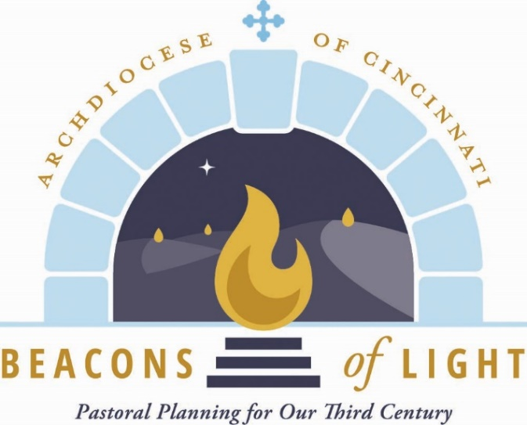
October 2021

Opening Prayer

Let us pray.

(Pause for silent prayer)

Mary, Mother of the Church and our Mother,
Present our prayer of thanksgiving to your Son.
Beg from Him the graces we need to be faithful disciples
who follow Him with enthusiasm and joy.
May our witness to the love of God bear fruit
in our archdiocese, parishes, homes and hearts.
Teach us to be God’s joyful witnesses,
to radiate Christ in all we do,
so that all people might know, love and follow your Son
through this life and into the next. Amen.
Grant, we pray, almighty God,
that your Church may always remain that holy people,
formed as one by the unity of Father, Son, and Holy Spirit,
which manifest to the world
the Sacrament of your holiness and unity
and leads it to the perfection of your charity.

Through our Lord Jesus Christ, your Son,
who lives and reigns with you in the unity of the Holy Spirit,
God, forever and ever. Amen.

Reading from Sacred Scripture

A reading from the Gospel according to St. Mark.

Jesus summoned the twelve and said to them,
“You know that those who are recognized as rulers over the Gentiles
lord it over them,
and their great ones make their authority over them felt.
But it shall not be so among you.
Rather, whoever wishes to be great among you will be your servant;
whoever wishes to be first among you will be the slave of all.
For the Son of Man did not come to be served
but to serve and to give his life as a ransom for many.”

(Mk 10:42-45) Twenty-ninth Sunday in Ordinary Time)

From Families of Parishes: Journeying Together

We are a “pilgrim Church,” journeying toward the heavenly Jerusalem. Significantly, in Lumen Gentium (LG, 9-17), the Dogmatic Constitution on the Church, the Second Vatican Council addresses the “People of God” before addressing the hierarchy. Prior to this document, a pryramidal view of the Church, with the bishops and priests on top and the laity on the bottom, dominated. With the document’s promulgation all the baptized, with their distinctive roles, could understand their vocations as a service to the Church.

By Father Earl Fernandes
The Catholic Telegraph is featuring articles written by Fr. Fernandes to provide theological foundations for Beacons of Light. These foundational articles will be used in the monthly Beacons of Light prayers and throughout the Beacons process.

