Questions for Reflection and Sharing

What connections or new insights did you gain from the readings?

What words or phrases spoke to you most powerfully
in light of the call to form our parish as a beacon of light?

How might the readings influence our planning for the future?

Intercessions

For what or for whom should we pray?

Lord’s Prayer
Closing Prayer

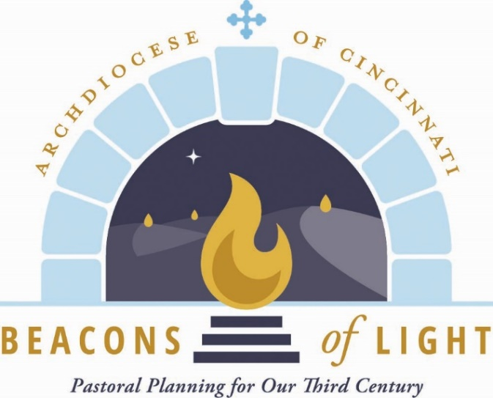
November 2021

Opening Prayer

Let us pray.

(Pause for silent prayer)

Mary, Mother of the Church and our Mother,
Present our prayer of thanksgiving to your Son.
Beg from Him the graces we need to be faithful disciples
who follow Him with enthusiasm and joy.
May our witness to the love of God bear fruit
in our archdiocese, parishes, homes and hearts.
Teach us to be God’s joyful witnesses,
to radiate Christ in all we do,
so that all people might know, love and follow your Son
through this life and into the next. Amen.
Grant, we pray, almighty God,
that your Church may always remain that holy people,
formed as one by the unity of Father, Son, and Holy Spirit,
which manifest to the world
the Sacrament of your holiness and unity
and leads it to the perfection of your charity.

Through our Lord Jesus Christ, your Son,
who lives and reigns with you in the unity of the Holy Spirit,
God, forever and ever. Amen.

Reading from Sacred Scripture

A reading from the first letter of St. Paul to the Thessalonians.

Brothers and sisters:
May the Lord make you increase and abound in love
for one another and for all,
just as we have for you,
so as to strengthen your hearts,
to be blameless in holiness before our God and Father
at the coming of our Lord Jesus with all his holy ones. Amen.
Finally, brothers and sisters,
we earnestly ask and exhort you in the Lord Jesus that,
as you received from us
how you should conduct yourselves to please God
and as you are conducting yourselves
you do so even more.
For you know what instructions we gave you through the Lord Jesus.

(1 Thes 3:12-4:2) First Sunday of Advent)

From The Church as the Family of God

From Families of Parishes: Journeying Together

A synodal Church is one that listens and “which realizes that listening is more than simply hearing.” This involves listening not only to one another, but also to the Holy Spirit to know what “he says to the churches” (Rev. 2:7). Listening affirms each person’s dignity and expresses respect for the voices, legitimate desires, problems and sufferings of the People of God.
The process of listening begins with the People of God, who, by virtue of their baptism, share in the prophetic office of Christ. Priests and bishops, attentive to the voice of the flock, listen to God to act rightly and give credible witness to the apostolic faith. The process converges to a point of unity in faith, facilitating an encounter with the Lord in truth.

By Father Earl Fernandes
The Catholic Telegraph is featuring articles written by Fr. Fernandes to provide theological foundations for Beacons of Light. These foundational articles will be used in the monthly Beacons of Light prayers and throughout the Beacons process

The Catholic Telegraph is featuring articles written by Fr. Fernandes to provide theological foundations for Beacons of Light. These foundational articles will be used in the monthly Beacons of Light prayers and throughout the Beacons process.

