The Spirit of
Sr. Dorothy Stang Award
Dorothy Mae Stang, a native of Dayton, Ohio, and
a Sister of Notre Dame de Namur, was murdered in

Anapu, in the heart of the Amazon in Brazil on February 12, 2005. She was outspoken in her efforts on behalf of the environment and those
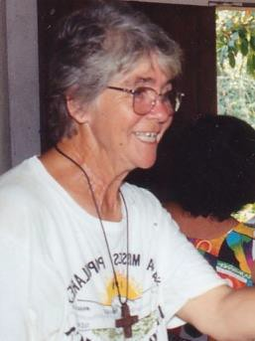
living in poverty.
Sr. Dorothy was missioned to Brazil in 1966 along with four other Sisters of Notre Dame de Namur. They established a new convent and began their ministry. As they learned about the
oppression of farmers at the hands of land- owners, they began to teach the people about their rights as human beings.
In the early 1970s the Brazilian government offered land in the Amazon region to farmers who wished to move there if they could develop the land in a sustainable way while protecting the forest. As they moved into the interior, Sister Dorothy joined them, working with them to develop sustainable projects.
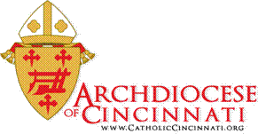
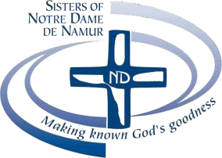
Her dream was simple, but very threatening to the wealthy loggers and cattle raisers who profited from their illegal businesses and destroyed both the land and the forest as well as the lives of the poor farmers and their families. As her own life was in great danger, Dorothy never thought of leaving, worrying only about the people whose lives she shared and the harassment they endured.
On the day before her assassination, she went to the local police to request protection at an important meeting the following morning. They told her that there was no police vehicle available. The rest is history, and the story of what happened on the village path leading to the meeting is well known. Carrying only her little bag of important land documents and her Bible, Sister Dorothy was well prepared for her meeting, unaware of the two hired pistoleros who were just ahead of her. At a little turn in the road, she came face-to-face with her murderer aiming his gun straight at her head. She knew then that her life’s mission was over.
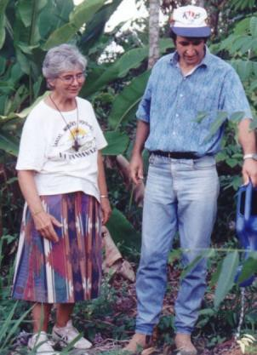
Pulling out her small Bible, she began reading the words of Jesus, “Blessed are the poor …” (those Sister Dorothy spent her life serving) …” Blessed are those who hunger and thirst for justice….” (her entire life in a nutshell). Six shots echoed in the silence of the forest.
Dorothy was not “buried.” The people said they “planted” her there in the forest on the spot where she died where her spirit and hope continue to blossom and bear fruit. The people she lived and worked with call her Saint Dorothy, and indeed she is.

~ ~ ~ ~ ~ ~ ~ ~ ~ ~ ~ ~ ~ ~ ~ ~ ~ ~ ~ ~ ~ ~ ~ ~ There are many saints like Sr. Dorothy in the Archdiocese of Cincinnati: people of all ages who work tirelessly for justice and peace, care for the poor and the integrity of creation Let’s celebrate them!

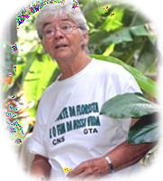

Parish Nomination Form for
Fall 2023 (page 1)
Awarded to only one qualified nominee from EACH
Catholic parish in the Cincinnati Archdiocese
Granted by the Sisters of Notre Dame de Namur and
the Archdiocese of Cincinnati Mission Office

Purposes of the Award:
- To keep alive the ministry and memory of Sister Dorothy Stang. That includes her Christ-like commitment with people who are poor, marginalized, or forgotten. And her dedication to Catholic Social Justice Teachings on peace, justice, and love of God’s creation.
- To encourage parishes to study/teach about Sister Dorothy and encourage others to follow in her footsteps by promoting environmental consciousness, love for those living in poverty, and involvement in mission, and/or cross-cultural activities/ministries.
- To honor parish ministers and parishioners who exemplify these values of Sister Dorothy in their
ministries and everyday lives.

Criteria for the Award:

Nominees: parishioner (youth or adult), family, team, or leader/staff member in a Catholic parish who:
  - have demonstrated Christ-like solidarity with people who are living in poverty, forgotten, and/or,
  - have demonstrated Care for the Earth/Environmental Consciousness, and/or,
  - have applied Catholic Social Teachings in mission or Cross-cultural activities/ministries.
Nominator and/or Parish Contact person: (someone in a direct working relationship with the nominee and able to arrange for the time and place of the award presentation)
Name Parish E-mail Phone

Approved by the pastor?................. His signature, if possible……………………………………………….

Please submit this Nomination Form to the Archdiocesan Mission Office by Sept. 1, 2023.
(This allows time to prepare a certificate and have it mailed to your parish before an Oct. 15 presentation)
Mail to: Dr. Mike Gable, Archdiocese of Cincinnati, Mission Office, 100 E. 8th St., Cincinnati, OH, 45202
E-mail: mgable@catholicaoc.org. For questions call the Mission Office at 513-263-6680.

Award Presentation: The award certificate will be mailed to the parish c/o the nominator before Oct. 15. The Mission Office requests that the pastor present the award at a weekend Mass on Oct. 14 or 15, 2023. That would be the weekend before World Mission Sunday, Oct. 22, 2023.

Parish Nomination Form
Fall 2023 (page 2)

Name of person/family to be nominated.
Please check one: ________Staff _________Parishioner
Parish
Parish Address

Please write clearly examples of how any of these three criteria below have been addressed by the person or family you are nominating. Submit an extra page as necessary.

This nominee has demonstrated the values of Sr. Dorothy Stang by:

Christ-like solidarity with people who are poor/marginalized:
__________________________________________________________________________________________________________________________________________________________________________________________________________________________________________________________________________________________________________________________________________________________________________________________________________________________________________________________________

Care for the Earth/Environmental consciousness:
__________________________________________________________________________________________________________________________________________________________________________________________________________________________________________________________________________________________________________________________________________________________________________________________________________________________________________________________________

Application of Catholic Social Teachings in mission, cross-cultural service, or teaching ministry:
__________________________________________________________________________________________________________________________________________________________________________________________________________________________________________________________________________________________________________________________________________________________________________________________________________________________________________________________________

** Also include a letter of reference from some within the populations whom your nominee has served.

You may wish to view a 30-minute video about Sr. Stang by
going on-line to You Tube to scroll for “Sister Dorothy Stang” and in
the search bar note, “The Student, the Nun, and the Amazon”
by Samuel Clemens.

