For Healing After Abortion
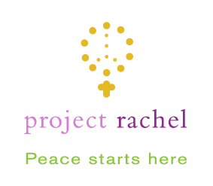
If you experience regret, guilt, or grief after abortion, be assured that God’s healing love and mercy are always available to the repentant heart.
For confidential, non-judgmental help, call (513) 784-0531 or visit https://projectrachelohio.org/

Healing After Abortion
Confidential, compassionate help is available.
Call 513-784-0531 to speak to someone who will listen and help.


Healing After Abortion
Confidential, compassionate help is available.
Call 513-784-0531 to speak to someone who will listen and help. Or, visit the Archdiocese of Cincinnati’s website: https://projectrachelohio.org/

