
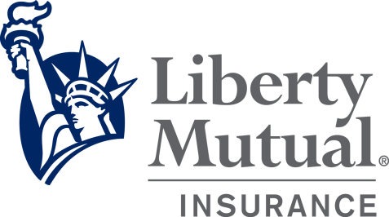

Equipment Breakdown

Jurisdictional Inspections

Locations insured for Equipment Breakdown (on a package, property or monoline EB policy) have equipment which may require periodic jurisdictional inspections of boilers and pressure vessels. The insurance company providing the Equipment Breakdown Coverage will conduct the inspections for the insured locations. Customer often ask:

WHO IS RESPONSIBLE FOR ENSURING THAT REGULATED EQUIPMENT IS INSPECTED AT THE REQUIRED INTERVALS, AND THAT THE REQUIRED CERTIFICATES OF INSPECTION HAVE BEEN RECEIVED?

Customers must be aware that the jurisdiction places responsibility of the owner or user of the equipment which must be prepare for and make application to have the equipment inspected at the required intervals. In many cases the insuring company inspector or the state inspector may schedule the equipment for the required inspection; however, this does not relieve the owner or user from that responsibility.

Most states (as well as some counties and cities) have laws and regulations which require the owner of boilers and pressure vessels to have an inspection conducted on the equipment and display a current certificate of operation issued by such jurisdiction attesting that the inspection was performed and the equipment complies with all requirements.

LMEB Engineers use the Jurisdictional Online System and/or State Databases to track certificate due dates and proactively schedule any required inspections with our customers. Nevertheless, at times our customers may contact Liberty Mutual to schedule an inspection or to speak with one of National Board Certified Engineers. For the convenience of our customers, we have established an Inspection Hotline where insureds, or their agents, can call or Email us any time with questions or to schedule an inspection.

Any Policy Holder seeking a jurisdictional inspection, can submit a request by calling or emaling us at:

Inspection Hotline: (877) 526-0020 or LMEBInspections@LibertyMutual.com
All requests will be responded to with 24 - 48 hours of receipt. For inspection requests, the assigned EB Risk Engineer will directly contact the insured to schedule within 24 – 48 hours. When requesting an inspection please include the following:
Current Policy Number | YB2-L9L-480466-015
Location Address
Contact Name
Contact Phone Number
Contact Email
We strive to provide the very best customer service. Visit the Equipment Breakdown Risk Engineering page for more information about jurisdictional inspections, our engineering services and contact information.

https://business.libertymutualgroup.com/business-insurance/coverages/equipment-breakdown-policy

